
CPT CodeSource Install & Update Guide
SurgiSource®
Table of Contents
Chapter 1: Introduction 3
1.1: Audience 3
1.2: Related Documents 3
1.3: Support 3
1.4: Software/Hardware Requirements 4
Chapter 2: Install CodeSource 5
2.1: Prerequisites 5
2.2: Download and unzip 5
2.3: Install CodeSource 8
Chapter 3: Login and Navigation 13
3.1: Login 13
3.2: Tabs 14
3.3: About the CPT Code fields 15
3.4: About UpdateCodeInput_All.txt 15
3.5: Error Codes 16
Chapter 4: Update CPT Codes 17
4.1: Updating CPT Codes for: All CPT Codes 17
4.2: Update CPT Codes for: Manually defined code ranges 20
4.3: Update CPT Codes for: Pre-defined code ranges 23
4.4: Update CPT Codes for: Medicare-approved codes only 26
4.5: Update CPT Codes for: Newly Medicare-approved codes only 29
Chapter 5: Manual CPT Code Update 31
Chapter 6: About Log Files 32
6.1: Install Log 32
6.2: Log File 32
6.3: Error Log file 33
6.4: Windows Event Viewer 34
6.5: Validate Install 35
Appendix A: About Multi-Server Installs 36

Introduction
This document contains the steps necessary to install and update CodeSource from January 2017 forward. Each December, CMS releases CPT Code updates, effective January 1 of the next year. This updates SurgiSource with the current CPT® Codes.

Audience
The guide is for the system administrator, business office manager or designated personnel responsible for maintaining CodeSource for your Facility. The user needs a working knowledge of PC computing, MS Windows, CodeSource, CPT and HCPCS Codes and CMS regulations.

Related Documents
The scope of this document is limited to the CPT code updates. Please refer to the following documentation for assistance with issues outside the scope of this document. These documents are available for download from the Source Medical eServices portal.
- SurgiSource YYYY CPT CodeSource Release Notes
Note: YYYY represents the applicable year.
- Hardware and System Requirements Guide
- SurgiSource User Manual
  - Billing Module
    - CPT Code Forms
      - Description field
      - Default Charge field
      - Revenue Codes field
      - ICD Proc field
    - Add a CPT Code
    - Edit a CPT Code
- SurgiSource Reports Binder
  - CPT Codes - 1020

Support
If at any time you have questions regarding this install, contact Client Services/Application Support:
Application | Support | Fax | Email
SurgiSource | 800-447-0104 | Fax: (203) 949-6298 | surgisourcesupport@sourcemed.net
Before scheduling an appointment, please make sure that the facility has a recent and valid backup of the database.
Note: Clients may obtain a CD with the updates. However, this item is billable. Contact Source Medical Client Services to obtain a copy on CD.
Note: As indicated in the Source Medical Customer Support Policy, any assistance provided by Source Medicals staff with the installation of the enclosed update may be billed at Source Medical’s current hourly rates.

Software/Hardware Requirements
- Refer to the Surgery Hardware Configuration Guide located on Client Services Portal.
- Requires a minimum of SurgiSource v5.0 core.
- Requires MS SQL Client Tools.
- Source Medical recommends installing CodeSource on a SurgiSource Server.
Note: However, CodeSource can be installed on a Client workstation with Microsoft SQL Server tools, a valid ODBC connection and correct DSN configuration.
- Required SQL Management Studio and SA or SIS_Admin login and password.

Install CodeSource

Prerequisites
Perform the following pre-installation tasks prior to installing the CodeSource update package:
- Download the Installer package.
- Review software requirements.
- Verify that all users have logged out of SurgiSource.
- Backup the SurgiSource database.
Note: This is EXTREMELY IMPORTANT. You should not attempt this upgrade without a current, verified backup of your database.
- Locate the drive and directory location of the SurgiSource application (for example, C:\SISWIN).
- Validate the SA or SIS_Admin password.
Note: Any SQL Server ID with the appropriate Administrator rights can run the installation process.

Download and unzip
Create a temporary folder (C:\TEMP) on the facility local drive.
Navigate to the Client Services Login page.
The Client Services Please Login page appears:

Type in login credentials.
Click Login.
Click Product Releases on the left bar menu.
The system displays the following Product Releases page:
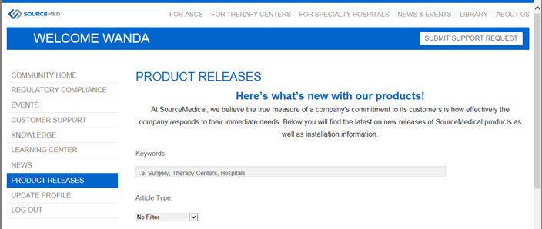
Download the self extracting SurgiSource YYYY CPT CodeSource Update exe file to the C:\Temp folder.
Note: YYYY represents the applicable year.
Note: For security reasons, do not use the Run command for this download.
Navigate to the C:\Temp.
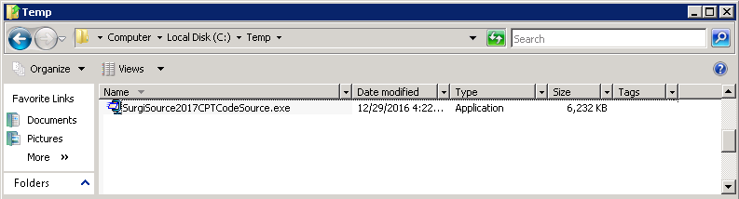
Double-click the SurgiSourceYYYYCPTCodeSource.exe file.
Note: YYYY represents the applicable year.
The Extractor window opens.
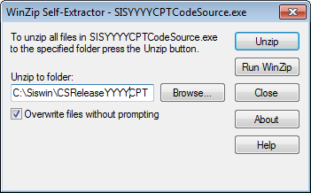
Click Unzip.
Note: By default, CodeSource is extracted to the C:\SISWIN\CSReleaseYYYYCPT folder. Source Medical strongly recommends using the default location. YYYY references the applicable year.
When prompted, type the password.
Note: If this password is unknown, please contact Support.
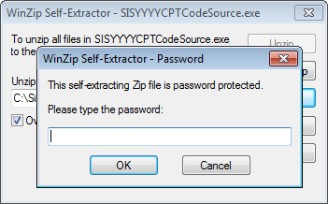
Click OK.
The executable file extracts.
The WinZip Self-Extractor dialog box appears.
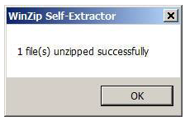
Click OK.
Click Close.
Navigate to C:\Siswin\CSReleaseYYYYCPT.
Note: YYYY represents the applicable year.
To install, continue below.

Install CodeSource
Double-click SISCodeSourceSetup.exe.
Note: The below screen will only appear if CodeSource is already installed. If this is first time install, continue below.
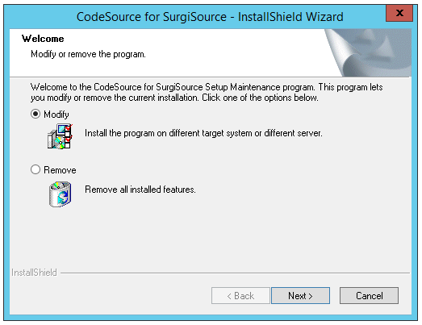
Click the Modify radio button.
Click Next.
Wait until the ‘CodeSource for SurgiSource – InstallShield Wizard’ window appears.
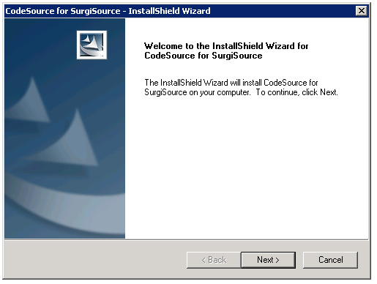
Click Next.
The Gathering Installation Information window appears.
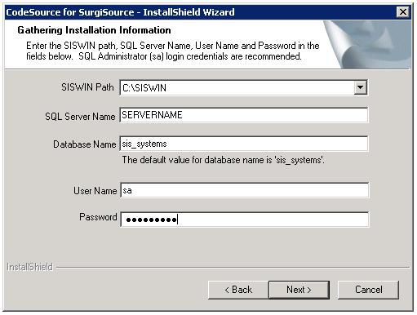
In the SISWIN Path field, verify the correct path.
If path in incorrect, select correct path in the drop down field.
Note: The CodeSource Installer will search all drives for all instances of the SISWIN folder. All instances display in the dropdown field.
In the SQL Server Name field, type the SQL Server Name for the SurgiSource database.
In the Database Name field, verify the name of the SurgiSource database.
Note: By default, the database name is sis_systems.
In the User Name field, type:
SA
In the Password, type the password.
Click Next.
Note: If one or more of the fields above are left blank, the system will display the below dialog box prompting the User to enter the indicated information.
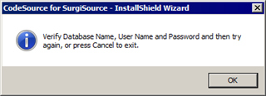
The Confirm Installation window appears.
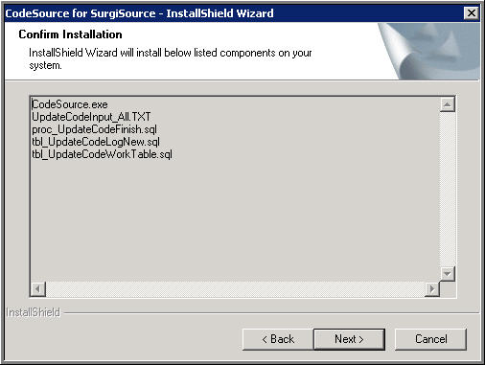
Carefully review the screen.
Click Next.
The Ready to Install the Program window appears.
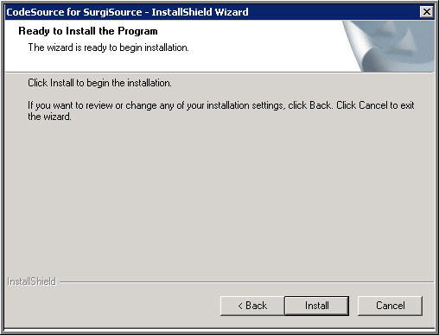
Click Install.
When the installation is complete, the InstallShield Wizard Complete screen displays
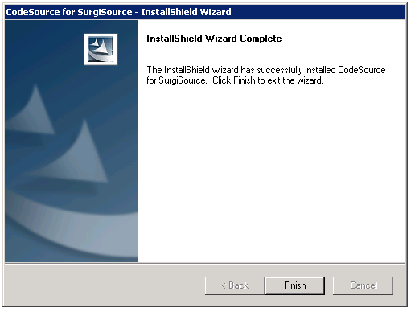
Click Finish
Review the Install Log.
To complete the CodeSource Update, continue below.

Login and Navigation

Login
Navigate to the SISWIN directory.
Double-click the CodeSource Application file.
The Administrator Login screen displays.
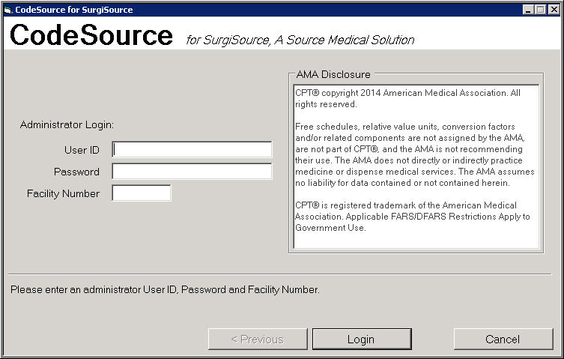
In the User ID field, type the user id.
Note: Either the SA or SIS_Admin user id is acceptable.
In the Password field, type the password.
In the Facility Number field, type the facility number.
Note: If CodeSource is configured to update multiple servers, the Facility Number field does not display.
Click Login.
The CodeSource for SurgiSource window displays:
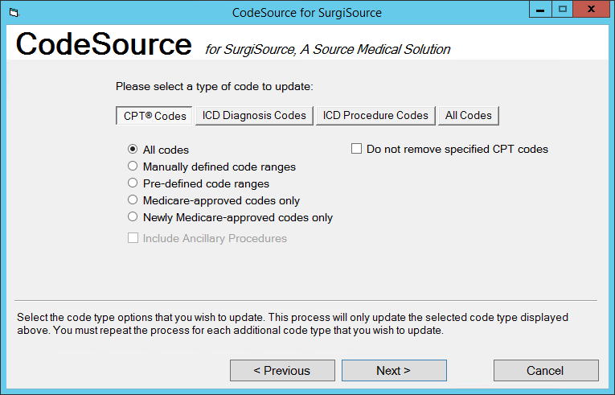

Tabs
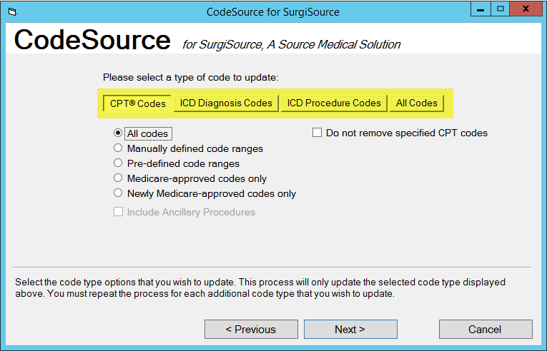
Code Type Option | Description
CPT Codes | This option provides the ability to add or update CPT Codes. Additionally, users can elect to not remove CPT codes.
ICD Diagnosis Codes | Refer to the SurgiSource ICD User Guide for additional information. This guide is located on Source Medical E-Services Portal.
ICD Procedure Codes | Refer to the SurgiSource ICD User Guide for additional information. This guide is located on Source Medical E-Services Portal.
All Codes | Refer to the SurgiSource ICD User Guide for additional information. This guide is located on Source Medical E-Services Portal.

About the CPT Code fields
Fields | Description
Radio Buttons
All codes | Select this option to update all CPT codes. This option is selected by default.
Manually Defined code ranges | Select this option to update CPT codes using ranges entered manually in CodeSource.
Pre-defined code ranges | Select this option to update CPT codes using pre-defined ranges selected in CodeSource.
Medicare-approved codes only | Select this option to update only Medicare-approved CPT codes.  Note: The Include Ancillary Procedures check box is enabled only when the user select one of the Medicare-approved codes options. This updates only the Medicare-approved Ancillary CPT Codes.
Newly Medicare-Approved codes only | Select this option to update only new Medicare-approved CPT codes.  Note: The Include Ancillary Procedures check box is enabled only when the user select one of the Medicare-approved codes options. This updates only the Medicare-approved Ancillary CPT Codes.
Checkboxes
Do not remove specified CPT codes | Enable to not remove CPT® codes from the table, if not present in the updated release.  Note: Navigate to the CPT® Code table and verify the Non Specified Procedures checkbox is enabled for each procedure in question.

About UpdateCodeInput_All.txt
If CodeSource locates the code input file (UpdateCodeInput_All.TXT) and the input file loads correctly, CodeSource continues to the next step in the process and displays the window.
The CodeSource input file is stored in the SISWIN folder.
This is a text file containing the CPT updates.

Error Codes
- If UpdateCodeInput_All.TXT is not found, the following message displays.
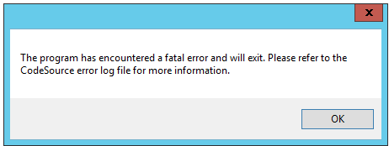
  - Refer to Error Log file or Windows Event Viewer.
Note: During a multi-system CodeSource update, this message is not displayed if the error applies to a specific server. This does not prevent the program from updating another server.
- If UpdateCodeInput_All.TXT is empty, the following message displays.
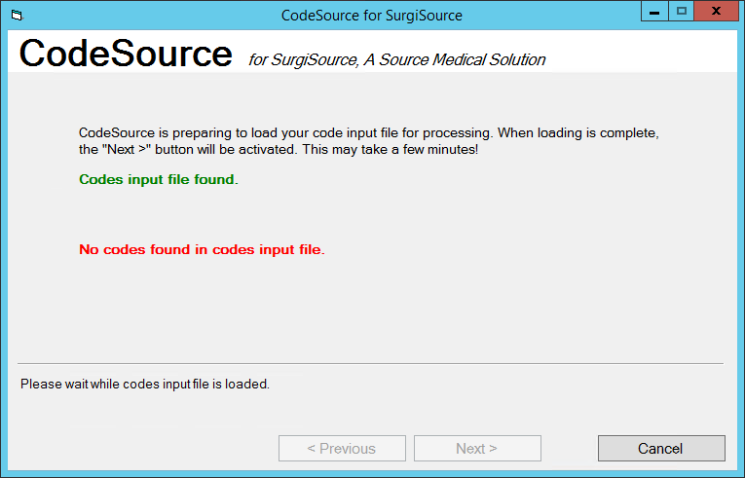

Update CPT Codes
The information in this section will provide details on updating CPT codes with CodeSource.
About New CPT Codes
- For new codes, this process inserts the actual CPT Code and AMA description.
About Existing CPT Codes
- For existing codes, the payment indicator field is updated if different from the indicator in the input file (Except when updating Medicare-approved codes only. The code description will not be updated.)
- Existing codes, not in the code input file, are marked suspended.
  - This function is not affected by any defined range of codes selected.
Note: Before beginning the CPT update, review the Prerequisites.

Updating CPT Codes for: All CPT Codes
To update SurgiSource with CPT Codes using CodeSource:
On the CPT Codes tab, select All Codes.
If CodeSource locates and loads the code input file, the Select a type of code to update screen displays.
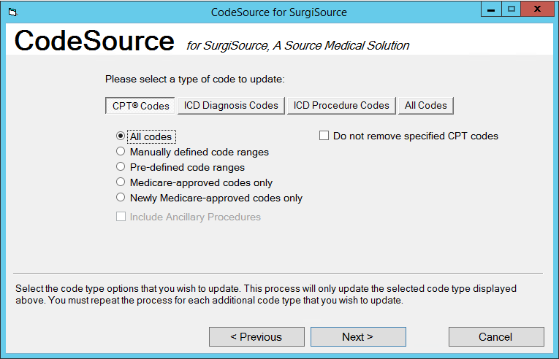
Click Next.
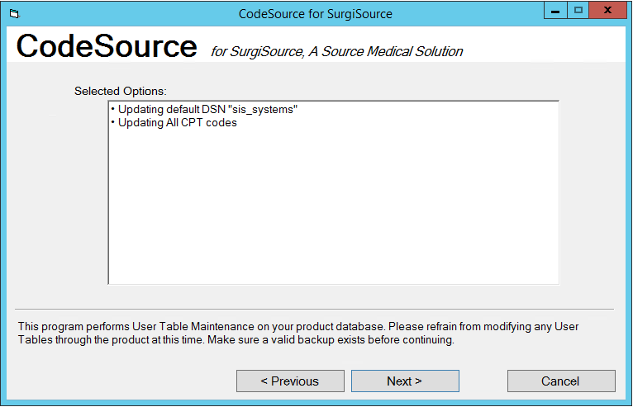
Note: When updating a single server, the DSN for the update process is listed. When updating multiple servers, the number of servers is listed.
Click Next.
The below window displays.
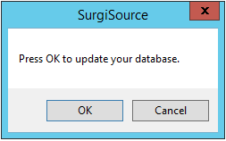
Click OK.
The CodeSource Process begins.
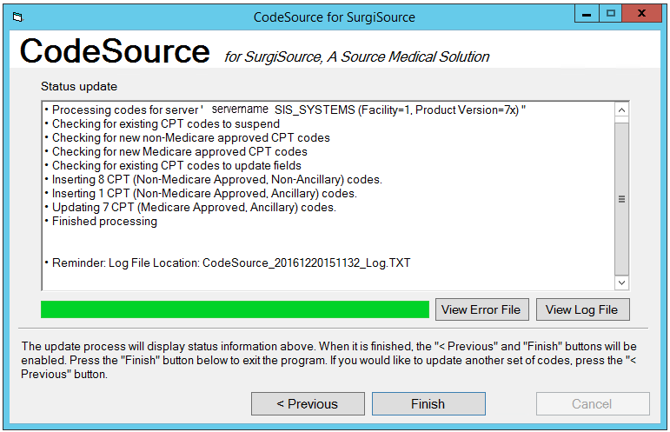
When complete, click Finish.
Or, click Previous to update additional codes.
For information about the log files, refer to About Log Files.
Note: The View Log File button is not available on this screen until the update process finishes.
To validate install, refer to Validate Install.

Update CPT Codes for: Manually defined code ranges
On the CPT Codes tab, select the Manually defined code ranges radio button.
Note: For information about each of the fields on this screen, see About the CPT Codes fields.
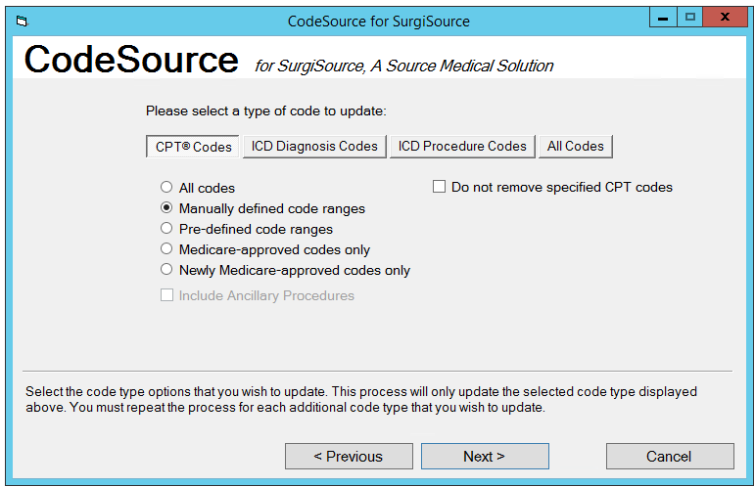
If desired, select additional checkboxes.
Note: For information about each of the fields on this screen, see About the CPT Codes fields.
Click Next.
The Select one or more systems window displays.
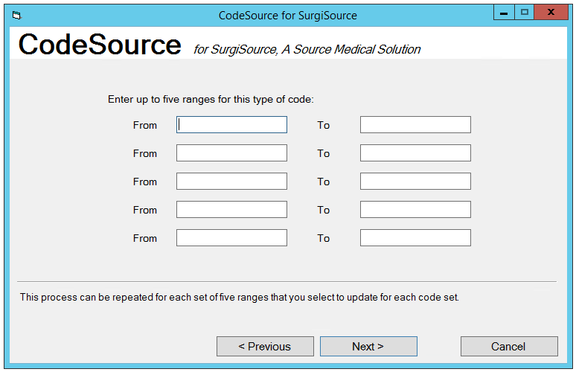
Type up to 5 ranges of CPT® codes in the From and To fields.
Note: If any ranges are entered in reverse order (for example, ‘greater value’ to ‘lesser value’), CodeSource will correct the order. The corrected range can be verified on the next screen.
Note: If no system/range values are entered on the window, CodeSource will default to updating ‘All codes’ for CPT codes.
Click Next.
The below window displays.
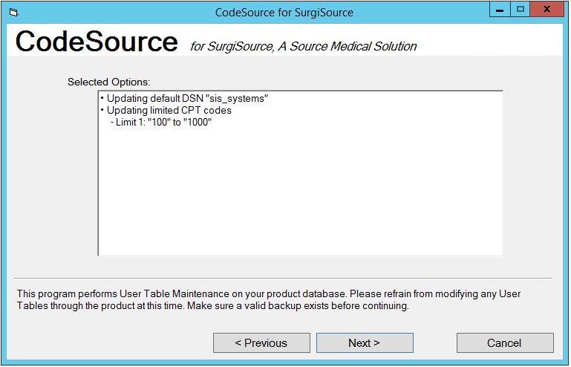
Note: When updating a single server, the DSN for the update process is listed. When updating multiple servers, the number of servers is listed.
Click Next.
The below window displays.
The CodeSource Process begins.
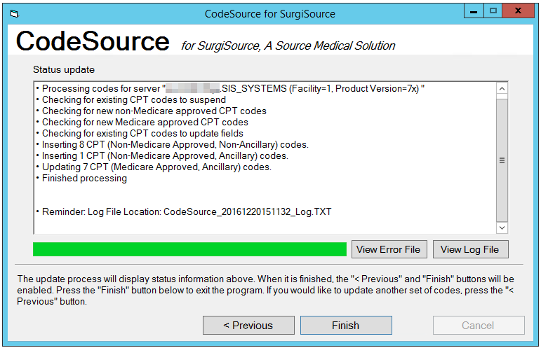
When complete, click Finish.
Or, click Previous to update additional codes.
For information about the log files, refer to About Log Files.
Note: The View Log File button is not available on this screen until the update finishes.
To validate install, refer to Validate Install.

Update CPT Codes for: Pre-defined code ranges
On the CPT Codes tab, select the Pre-defined code ranges radio button.
Note: For information about each of the fields on this screen, see About the CPT Codes fields.
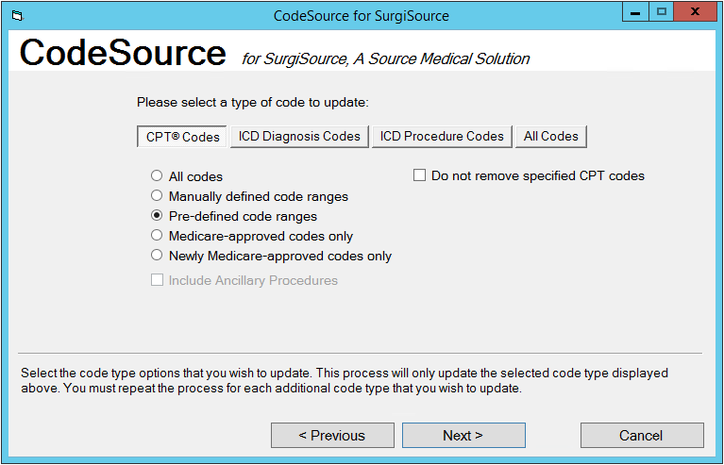
If desired, select additional checkboxes.
Note: For information about each of the fields on this screen, see About the CPT Codes fields.
Click Next.
The Select one or more systems window displays.
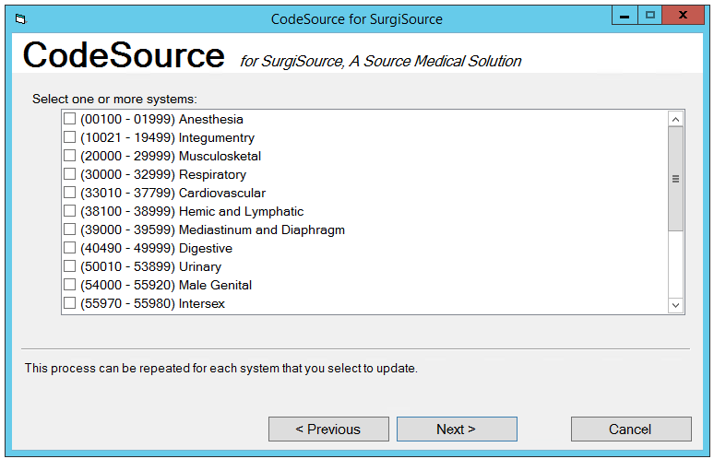
Select the desired systems.
Note: If no systems are selected, All CPT Codes are updated.
Click Next.
The Selected Options window displays.
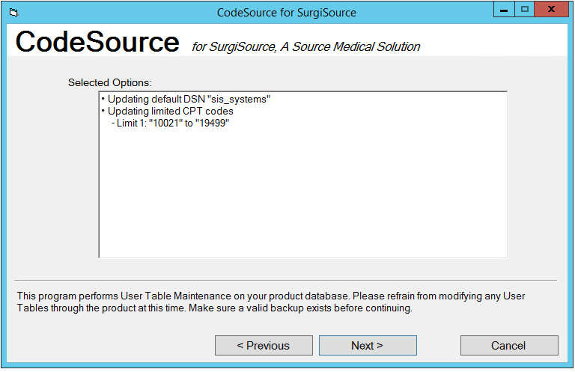
Note: When updating a single server, the DSN for the update process is listed. When updating multiple servers, the number of servers is listed.
Click Next.
The below window displays.
Click OK.
The CodeSource Process begins.
When complete, click Finish.
Or, click Previous to update additional codes.
For information about the log files, refer to About Log Files.
Note: The View Log File button is not available on this screen until the update completes.
To validate install, refer to Validate Install.

Update CPT Codes for: Medicare-approved codes only
On the CPT Codes tab, select the Medicare-approved codes only radio button.
Note: For information about each of the fields on this screen, see About the CPT Codes fields.
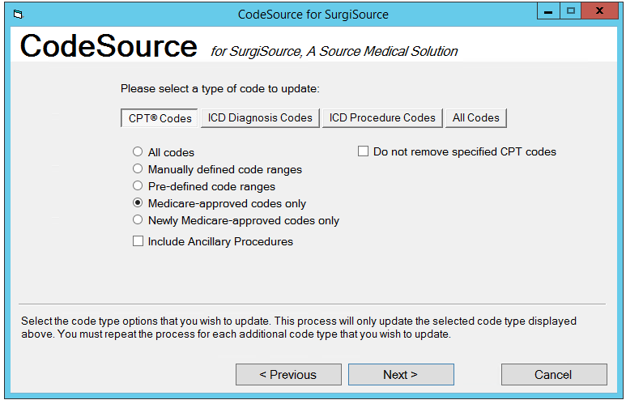
If desired, select additional checkboxes.
Note: For information about each of the fields on this screen, see About the CPT Codes fields.
Click Next.
The Selected Options window displays.
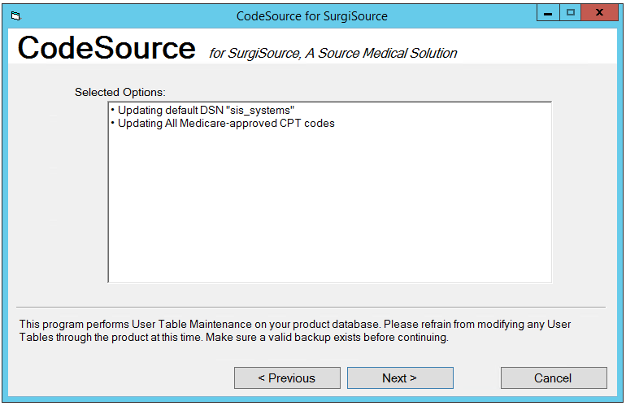
Note: When updating a single server, the DSN for the update process is listed. When updating multiple servers, the number of servers is listed.
Click Next.
The below window displays.
Click OK.
The CodeSource Process begins.
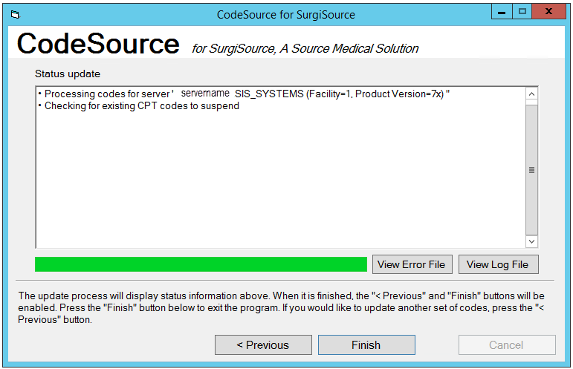
When complete, click Finish.
Or, click Previous to update additional codes.
For information about the log files, refer to About Log Files.
Note: The View Log File button is not available on this screen until the update completes.
To validate install, refer to Validate Install.

Update CPT Codes for: Newly Medicare-approved codes only
On the CPT Codes tab, select the Newly Medicare-approved codes only radio button.
Note: For information about each of the fields on this screen, see About the CPT Codes fields.
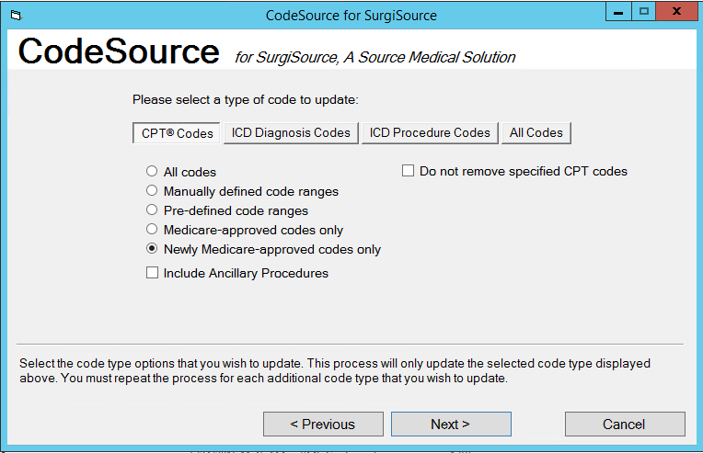
If desired, select additional checkboxes.
Note: For information about each of the fields on this screen, see About the CPT Codes fields.
Click Next.
The Selected Options window displays.
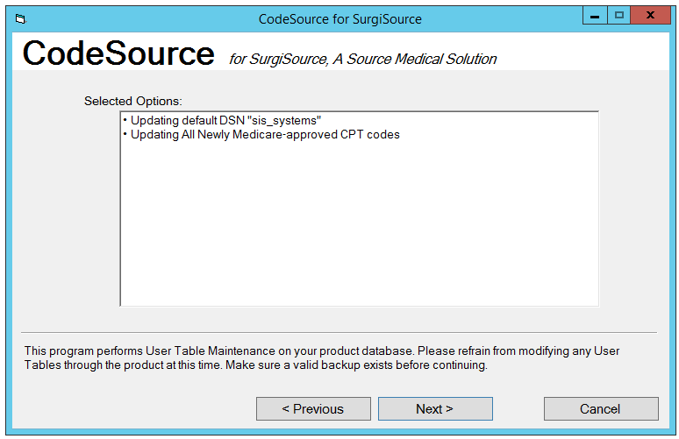
Note: When updating a single server, the DSN for the update process is listed. When updating multiple servers, the number of servers is listed.
Click Next.
The below window displays.
Click OK.
The CodeSource Process begins.
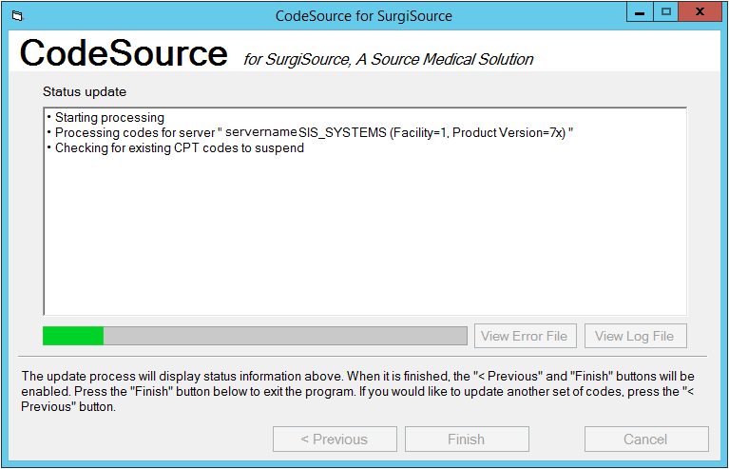
When complete, click Finish.
Or, click Previous to update additional codes.
For information about the log files, refer to About Log Files.
Note: The View Log File button is not available on this screen until the update completes.
To validate install, refer to Validate Install.

Manual CPT Code Update
To manually add or edit a CPT Code to SurgiSource, refer to the below topics in the User Manual:
- Billing Module
  - CPT Code Forms
    - Description field
    - Default Charge field
    - Revenue Codes field
    - ICD Proc field
  - Add a CPT Code
  - Edit a CPT Code
SurgiSource offers the below report to verify the CPT Code information. Refer to Reports Binder:
- CPT_Codes-1020
Note: The User Manual and the Reports Binder can be downloaded from the Source Medical E-Services Portal.

About Log Files

Install Log
The SISInstallLog.txt file will list any errors that occurred during the CodeSouce Install. The CodeSource log file is stored in the CodeSource folder, C:\SISWIN\CSReleaseYYYYCPT.
Note: YYYY represents the applicable year.
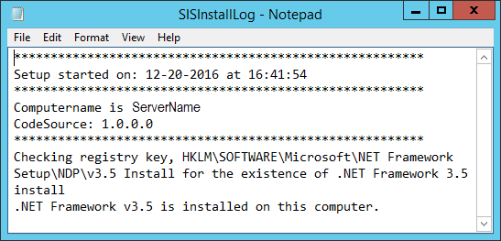

Log File
The CodeSource log file is named CodeSource_YYYYMMDDHHMMSS_Log.txt.
- Where YYYYMMDDHHMMSS represents the current date and time.
- The CodeSource log file is stored in the SurgiSource folder, C:\SISWIN.
CodeSource records information about the update, including errors, in the CodeSource log file. However, the detail for certain critical error messages will be written to the Windows Event Log. The log file will refer to the Event Viewer.
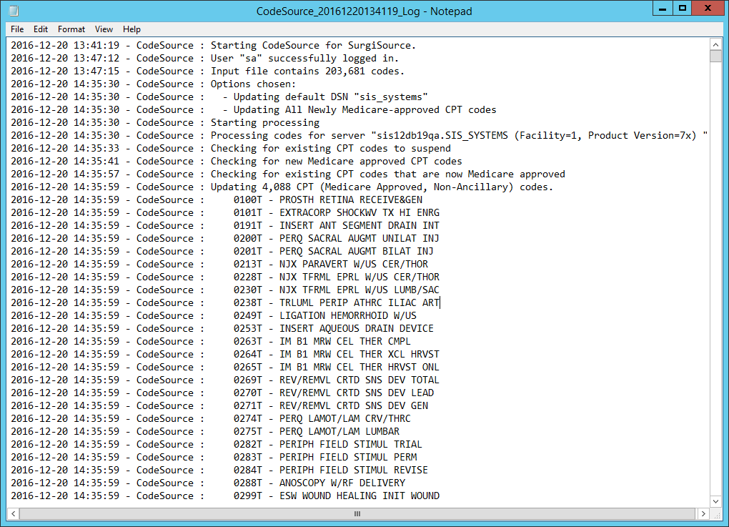

Error Log file
The CodeSource log file is named CodeSource_YYYYMMDDHHMMSS_Error.txt.
- Where YYYYMMDDHHMMSS represents the update date and time.
- The CodeSource log file is stored in the SurgiSource folder, C:\SISWIN.
Typically, CodeSource records errors that occur during the update in the CodeSource log. However, the detail for certain critical error messages will be written to the Windows Event Log.
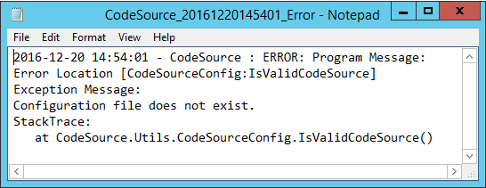

Windows Event Viewer
Perform the following tasks to review system errors using the Windows Event Viewer:
Go to Start> Control Panel > System and Security > Administrative Tools > Event Viewer.
The Event View opens.
Select Windows Logs > Application.
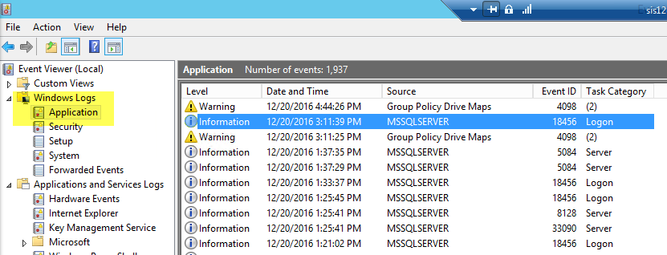
On the right side of the window, review the list of errors in the Application box and locate the system error in question. CodeSource system errors will have an entry in the Source column of CodeSource.
Use one of the following search methods to locate a specific error:
- Sort by Source to see all CodeSource errors grouped together.
- Sort by Date and Time to see the most current errors that have occurred.
Double-click the error event to review the details of the issue. When possible, resolve the error based on the indicated cause and other details provided.
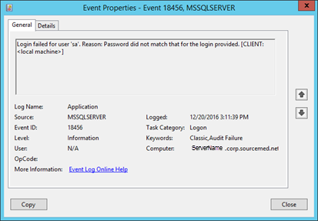
If necessary, contact Support.

Validate Install
To validate the CodeSource installation was successful, complete the below steps:
Review the contents of the SISInstallLog.txt file to determine if any errors were logged during the CodeSource Installation process.
Note: If the SISInstallLog.txt file does not indicate that any errors occurred during the installation process, the CodeSource installation was successful.
If the log does contain errors:
- Review the description of the error(s)
- Rerun the CodeSource Installer
- Contact Support.
- About Multi-Server Installs
CodeSource provides the ability to update multiple servers and databases during the execution of a single code update option. This functionality is particularly applicable for Corporate Clients who have many servers and need the efficiency of updating more than one server and/or database at a time.
To enable this multi-system update functionality, Clients have to configure each server/database to be updated in a CodeSource configuration file (provided with the CodeSource release). Then, when running a specific code update option from the module, CodeSource will update each Server/database correctly specified in the configuration file.
Note: For SurgiSource, the same SQL Server UserID and password (with Administrator rights) being used to conduct the update process must exist on all Servers/databases being updated for the update process to be successful. ‘SA’ login credentials are recommended.
In addition, CodeSource can perform the multi-system code update process for each ‘code type’ update option (when selected by the User in the CodeSource module).
Note: The default configuration file shipped with CodeSource is configured to update single systems by default. For a standard SurgiSource configuration, the configuration file is stored in SISWIN, directory. Prior to running the code update process for multiple servers, CodeSource must be installed on each server included in the configuration file.
In the CodeSource configuration file, server configuration items (<server> and </server> XML tags) are contained within <servers> and </servers> tags (which identify the server configuration items contained in the file). The <servers> and </servers> tags are contained within <sis> and </sis> tags (which determines the core surgery product to which CodeSource will connect).
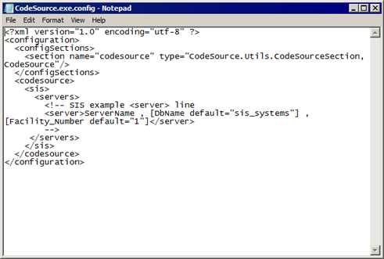
Within the <server> and </server> tags, the User can enter the server name, database name, and Facility number separated by commas (‘,’). For the server configuration item, the server name is required but the database name and Facility number are optional and can be left blank (as long as the required commas (‘,’) are included in the configuration entry, blank spaces are ignored and do not have to be entered). CodeSource will then use default values for each element when processing the server configuration item.
Before using CodeSource to update multiple servers for the same code update option (multi-system update process), the correct server configuration item must be created for each server in the CodeSource configuration file.
To configure CodeSource to update multiple servers:
- Navigate to the C:\SISWIN directory (on the drive where SurgiSource is installed).
- Open the CodeSource.exe.config file using Notepad or another text editor.
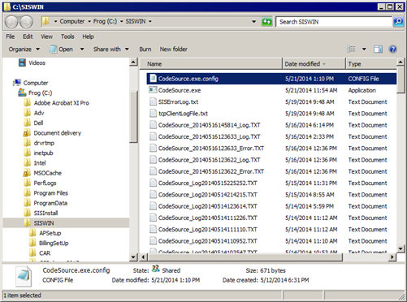
- When the CodeSource.exe.config file opens, the contents of the file are listed, which includes an example of a server configuration item for SurgiSource (see in the red box below).
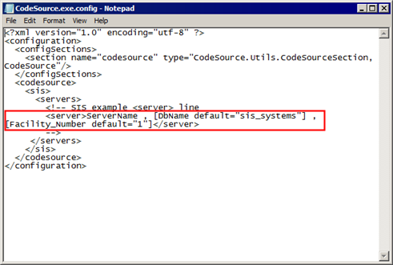
The following example of a server configuration item will be contained within a starting comment tag (‘<!--') and an ending comment tag (‘-->’) and will not affect the running of the CodeSource program (until moved out of the comment tags):
<server>ServerName , [DbName default="sis_systems"] , [Facility_Number default="1"]</server>
- From the open configuration file, copy the example of the server configuration item to a line above the starting comment tag (or below the ending comment tag as desired).
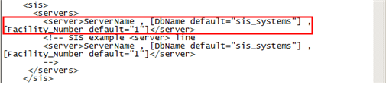
- For the server to be configured in the file, provide the following information for each element that makes up the server configuration entry (that was just copied) as indicated in the following example.
<server>ServerName , DbName, Facility_Number </server> where:
- ServerName – Server name (or server IP address).
- DbName – Database name. Enter the name of the SurgiSource database on the server (the typical, default database name is sis_systems. In addition, CodeSource treats this element as optional and assumes sis_systems as a default if the element is left blank.
- Facility_Number – Number for the facility that should receive the CodeSource updates. CodeSource also treats this element as optional and assumes 1 as a default if the element is left blank.
Note: If desired, you can create different server configuration items with the same server information but with a different number for the Facility_Number element in each configuration item. This will allow CodeSource to update all applicable facilities in the SurgiSource system on the server (as appropriate) during the same code update process.
Note: The text in brackets (‘[ ]’) indicate the name and default value of a specific element and should be replaced with the text value for the element as appropriate for the Server.
Although the second and third elements in the server configuration item for SurgiSource are optional and CodeSource defaults these elements to the indicated values, the commas for each element must still be included after the ServerName as indicated in the following example (spaces do not impact the syntax for the configuration elements).
The following indicates a valid example: <server>ServerName,,</server>
- After entering each element in the server configuration item, save the configuration file. The following provides an example of an updated server configuration item in the configuration file.
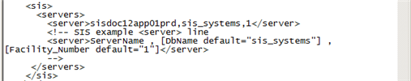
Note: If the server configuration item had been configured with the same server name but the database name and Facility number were left blank (with the appropriate commas {‘,’}), CodeSource would process the configuration item the same as the configuration item displayed above and default the database name and facility number to the appropriate values (‘SIS_Systems’ and ‘1’ respectively).
- As appropriate, now create a server configuration item for each server that needs to be included in the CodeSource configuration file (for the multi-system update process) using the process indicated above.
- After entering the server/database information in the appropriate entry for each server, review all of the configuration items for accuracy and completeness then save the CodeSource.exe.config file.
As an example, the CodeSource configuration file with multiple server configuration entries would appear similar to the following:
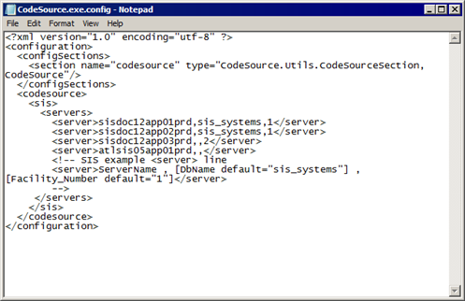
At this point, the CodeSource configuration file has been updated with multiple server configuration entries which CodeSource will process during the selected code update option (for each server configured correctly).
- When finished creating/editing server configuration items in the CodeSource configuration file, click File>Exit (after ensuring changes have been saved).
Note: The CodeSource configuration file can be revised at any time (when the module is not running) to add or update server configuration information as needed.
Note: If CodeSource encounters a server during the multi-system update process that cannot be accessed and/or is configured incorrectly, the program will skip that server then proceed to the next server.

